HS 3002 Principles of Economics

Tutorial Exercise 2 February 21, 2019

**1.** Draw a circular-flow diagram. Identify the parts of the model that correspond to the flow of goods and services and the flow of money for each of the following activities.

a. Samantha pays a storekeeper $1 for a quart of milk.

b. Sally earns $. 4.50 per hour working at a restaurant.

c. Serena spends $ 7 to see a movie.

d. Saran earns Rs.10,000 from his 10 percent ownership of Acme Industrial.

*Answer:*

Figure; the four transactions are shown.

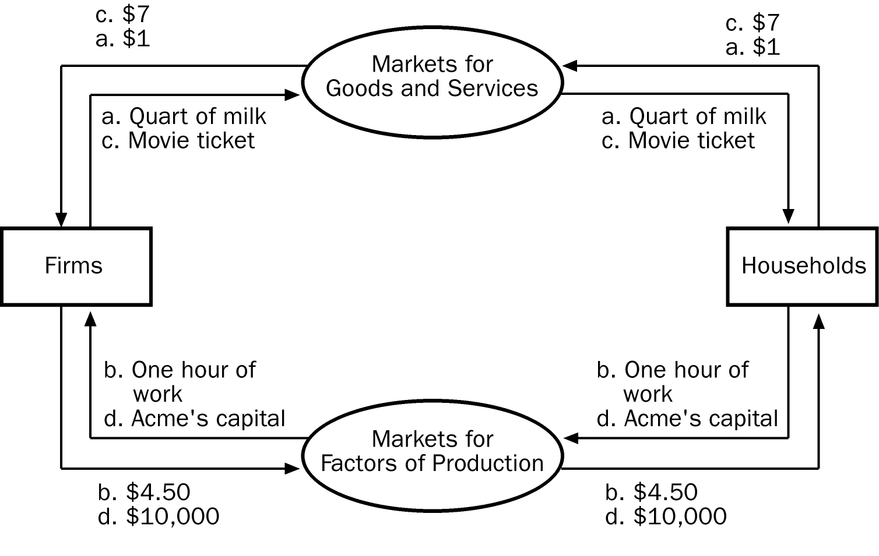

**2**. Use a production possibilities frontier to illustrate society’s tradeoff between a clean environment and high incomes. What do you suppose determines the shape and position of the frontier? Show what happens to the frontier if engineers develop an automobile engine with almost no emissions.

*Answer:*

The shape and position of the frontier depend on how costly it is to maintain a clean environment⎯the productivity of the environmental industry. Gains in environmental productivity, such as the development of a no-emission auto engine, lead to shifts of the production-possibilities frontier, like the shift from PPF1 to PPF2 shown in the figure.

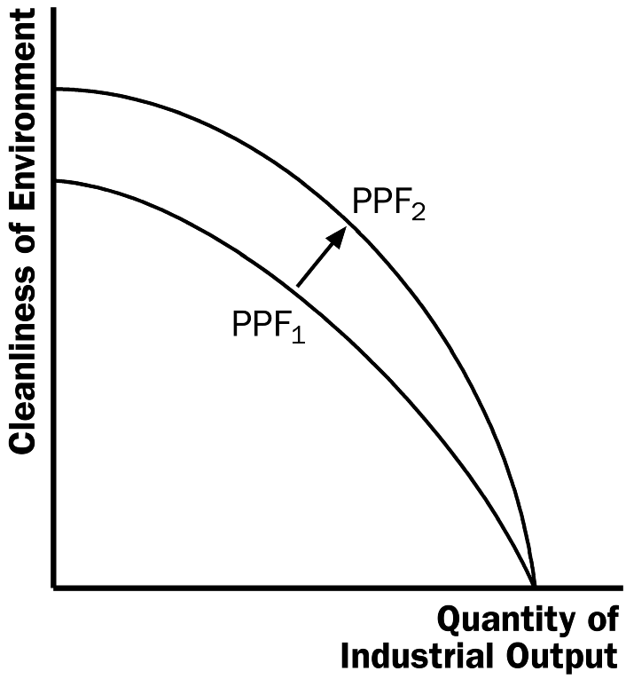

**Figure 7**

**3.** Consider public policy aimed at smoking.

a. Studies indicate that the price elasticity of demand for cigarettes is about 0.4. If a pack of cigarettes currently costs $2 and the government wants to reduce smoking by 20 percent, by how much should it increase the price?

*Answer:*

With a price elasticity of demand of 0.4, reducing the quantity demanded of cigarettes by 20 percent requires a 50 percent increase in price, since 20/50 = 0.4. With the price of cigarettes currently $2, this would require an increase in the price to $3.33 a pack using the midpoint method (note that ($3.33 - $2)/$2.67 = .50).

**4.** Suppose a worker in the United States can produce 4 cars or 20 computers per month while a worker in Russia can produce 1 car or 5 computers per month. Again, for simplicity, assume each country has only one worker.

a. Which country has the absolute advantage in the production of cars? Computers?

b. Which country has the comparative advantage in production of cars? Computers?

c.. Are there any gains to be made from trade? Why?

d. Does your answer in (d) above help you pinpoint a source for gains from trade?

*Answer:*

a. United States because one worker can produce 4 cars compared to 1.

The United States because one worker can produce 20 computers compared to 5.

b. In both, the opportunity cost of 1 car is 5 computers. In both, the opportunity cost of 1computer is 1/5 of a car. Therefore, neither has a comparative advantage in either good.

c. No. Each can get the same trade-off between goods domestically.

d.Yes. There needs to be differences in opportunity costs of producing goods across countries for there to be gains from trade.

**5.** You are given the following information about the market for motorcycles.

Market Demand: P = 400 – 4Q; Market Supply: P = 4Q

a). Find the equilibrium price and quantity in this market.

b). Compute the values of consumer surplus and producer surplus in this market?

c). Suppose that the government decides to impose an excise tax of $80 per motorcycle on producers in this market. What will be the number of motorcycles sold in this market once this tax is imposed?

d).Given the tax described in part (c), what will be the tax incidence on consumers? Given the tax described in part (c), what is the value of the deadweight loss from the tax?

e). What is the loss in producer surplus from the imposition of the excise tax described in part (c)?

*Answer:*

400 – 4Q = 4Q; 8Q = 400 Q = 50 motorcycles

P = 4(50) = $200 per motorcycle

CS = (1/2)($400/motorcycle – $200/motorcycle)(50 motorcycles) = $5000

PS = (1/2)($200/motorcycle – $0/motorcycle)(50 motorcycles) = $5000

The new supply curve with the excise tax will be P = 80 + 4Q. Using this equation and the demand equation we can solve for the new quantity of motorcycles sold once the excise tax is imposed. Thus, 80 + 4Q = 400 – 4Q or 8Q = 320 and Q = 40 motorcycles.

To find the tax incidence we must first find the price consumers pay once the excise tax is imposed. When Q = 40 motorcycles, the price consumers pay is P = 400 – 4Q or P = 400 – 4(40) = $240/motorcycle. The excise tax raises the price to consumers from $200 to $240. Thus, the consumer tax incidence can be calculated as the change in price times the number of motorcycles sold once the tax is imposed. Thus, CTI = ($240/motorcycle -$200/motorcycle)(40 motorcycles) = $1600.

DWL = (1/2)($240/motorcycles – $160/motorcycles)(10 motorcycles) = $400

The loss is producer surplus is equal to the area of a rectangle and the area of a triangle. The producer loses some of their surplus when the government captures it as tax revenue. The producer also loses some of their surplus due to the part of the deadweight loss from the tax that falls on producers. Thus, the loss is producer surplus is equal to ($200/unit - $160/unit)(40 units) + (1/2)($200/unit - $160/unit)(50 units – 40 units) = $1600 + $200 = $1800.